Multi-platform approach for automatic avalanche detection from satellite imagery

Intro:

Avalanche occurrences time and location is the most critical piece of information in an avalanche forecaster's arsenal. Currently, avalanche forecasters rely on people's observation of avalanche occurrences in their forecasts. However, we have no knowlage of what portion of the actual number of avalanches gets reported, and we know that reported avalanches are disproportionally larger near roads and dense populations. Knowing when and where avalanches occur across an entire zone will help improve avalanche forecasting, planning, avalanche research, and more.

Satellite-based avalanche detection is relatively cheap, safe, and can cover large areas with relatively small additional resources. To our knowledge, currently, there is only one satellite base avalanche detection system in Norway. This system uses Sentinel -1 satellite SAR images. The advantage of SAR images is the ability to "see" through cloud cover. However, SAR-enabled satellite coverage is too sparse over lower latitudes. Satellites with visible spectrum images over lower latitudes are more common but lack the ability to "see" through cloud cover. Here we present a framework for satellite images acquisition for CAIC and USGS collaborative plan to develop a multi-platform automatic satellite base avalanche detection system.

Area for satellite image acquisition:

For the winter of 2021-2022 model training and verification area, we selected a 1079 square km area for our satellite acquisition, centered around Eisenhower Tunnel (Figure 1). This area covers three busy highway corridors (I-70 from Empire to Summit County, Berthoud Pass, and Loveland Pass) with known avalanche activity. We chose this area because it has substantial avalanche activity, good ground truth verification capabilities. It is essential to Colorado's economy, and the CAIC is already conduction other research projects in this area.

Satellite images acquisition time and frequency:

Images acquisition follow a three-tier approach:

1. General monitoring – a once a week WorldView images
2. During a storm – Daily WorldView and RADARSAT images
3. After the storm – WorldView images

WorldView images are Multispectral, 16 bits GeoTiff OrthoReady (2A) Imagery, resampled, and kernel enhanced.

RADARSAT images are four channels (HH, VV, HV, and VH) images with fine resolution (8 m/pixel)

Sentinel -1 SAR images will be used depending on availability.

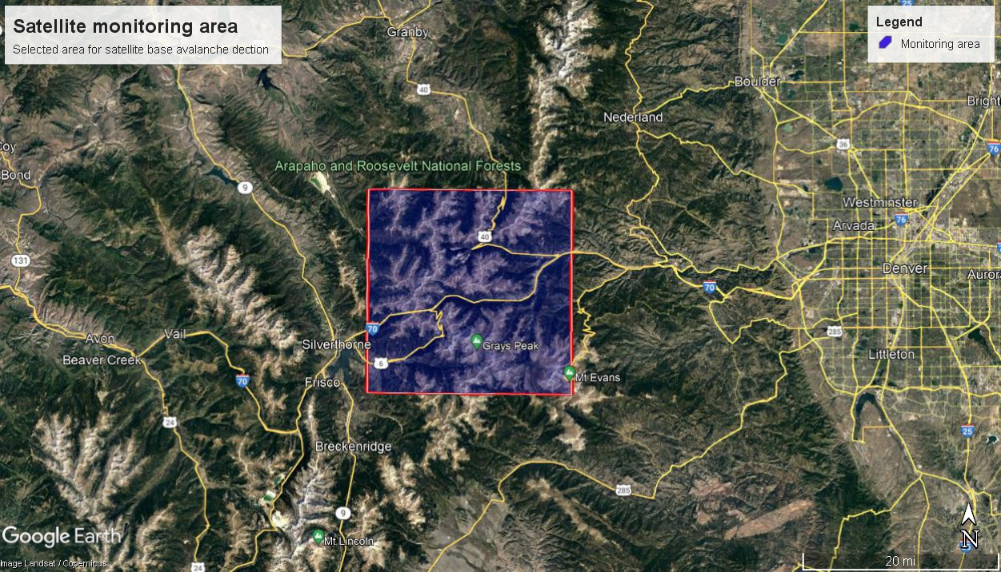

Figure 1: Requested Satellite images cover area